Computer Network Model Practical
Name: Ashwanth SP
Reg No:1921260012
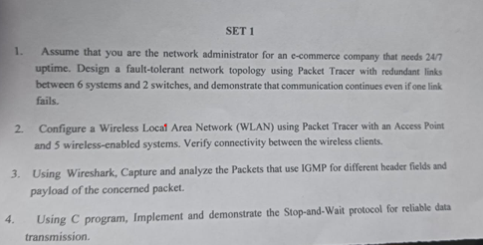
Model Practical Exam
Question 1:
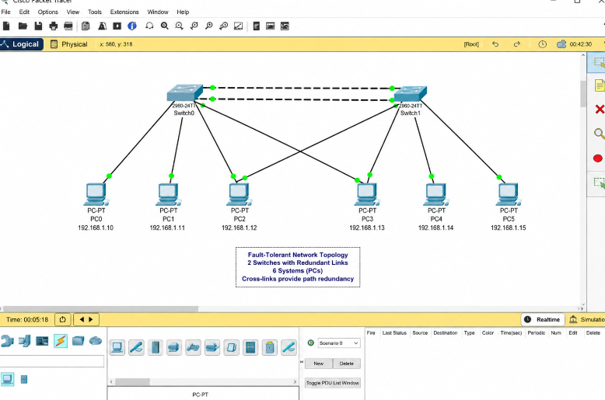
Model Practical Exam
Question 2:
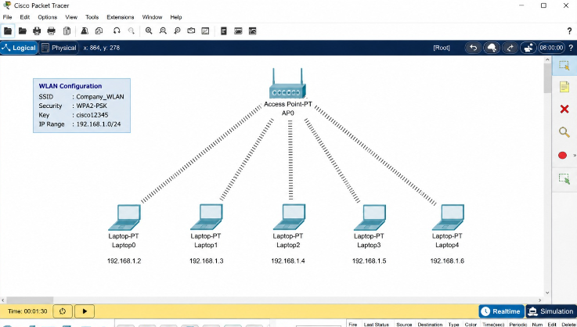
Model Practical Exam
Question 3:
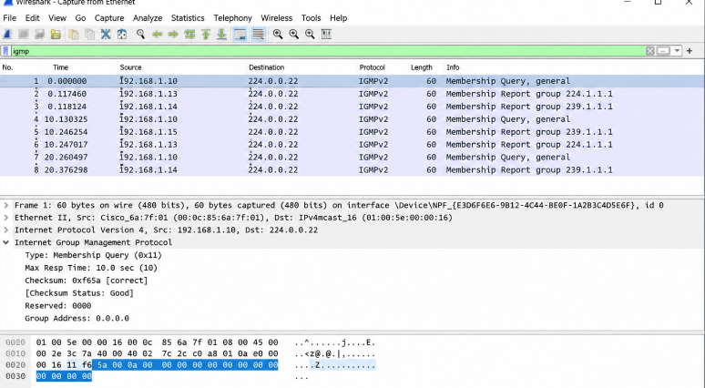

Model Practical Exam
Question 4:
